**UI DESIGNING**

User interface design ***(UI)*** or user interface engineering is the [design](https://en.wikipedia.org/wiki/Design) of

User Interface for [machines](https://en.wikipedia.org/wiki/Machine) and [software](https://en.wikipedia.org/wiki/Software), such as [computers](https://en.wikipedia.org/wiki/Computer), [home appliances](https://en.wikipedia.org/wiki/Home_appliance),

mobile devices, and other [electronic devices](https://en.wikipedia.org/wiki/Electronics), with the focus on maximizing [usability](https://en.wikipedia.org/wiki/Usability)

and the [user experience](https://en.wikipedia.org/wiki/User_experience).

The goal of user interface design is to make the user's interaction as simple and efficient as

Possible.

1. For the creation of UI designing we need UI technologies that is HTML, CSS, etc…

Now HTML and CSS are Updated and as ***HTML5 and CSS3.***

And for creation of effective Designing we have Bootstrap and W3c and jquery etc…

1. Html contains a predefined tags, by using tags we can easily develope the UI.

Html is used to make our UI fields to visible like username and password etc..

Meanwhile make a styles to that fields by using ***css (Cascading style sheets).***

CSS is for describing the presentation of Web pages, including colors,

layout, and fonts. It allows one to adapt the presentation to different types of devices,

such as large screens, small screens, or printers

1. Css can write with in the html page. Or else outside the html page also.

If, you write outside the html page, then u need to include that css page to html page by using

the ***link*** tag. Then only it will work.

**Sample Code by using HTML and CSS:**

In the Following snippet, using link tag we included the external css file. Like this we

can create a variable web pages.

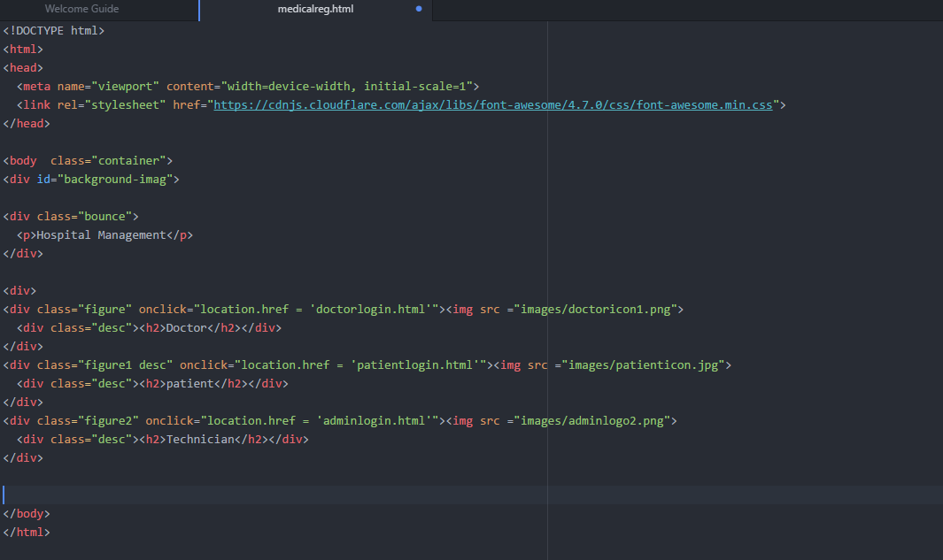

**Bootstrap:**

Bootstrap is nothing but HTML, CSS, JAVASCRIPT framework for developing responsive

mobile applications.

* Bootstrap is a free front-end framework for faster and easier web

Development

* Bootstrap includes HTML and CSS based design templates for

typography, forms, buttons, tables, navigation, modals, image

carousels and many other, as well as optional JavaScript plugins

* Bootstrap also gives you the ability to easily create responsive designs

Mostly it is Grid based, it will allow 12 column’s along the page.

If we do not want to use all 12 columns individually, you can group the

columns together to create wider columns:

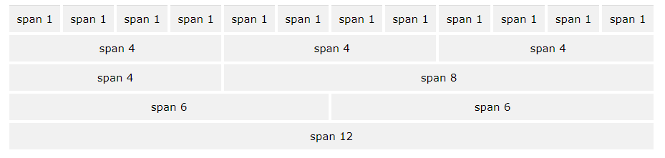

By using like grid based , then it is easy to understand and easy to develop. And user

attractive. Bootstrap mostly contains attractive predefined tags.

***Example***

**1)Creating Dynamic Web Project:**

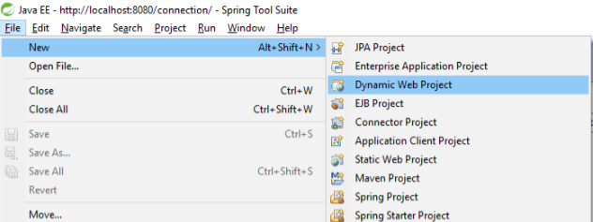

**2)Project Structure**

Place all .html files in Yourproject-->WebContent-->WEB-INF--> html

We Can also create our Own folders in WEB-INF with respect to project Requirement.

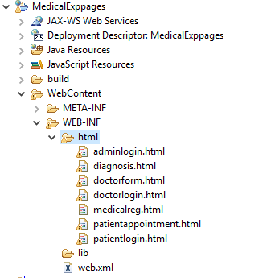

**3)For pure html pages no need to add jars.**

**4)**

**Index page:**

Home page designed with Html and css snippet icons then it go to the related register and

login pages

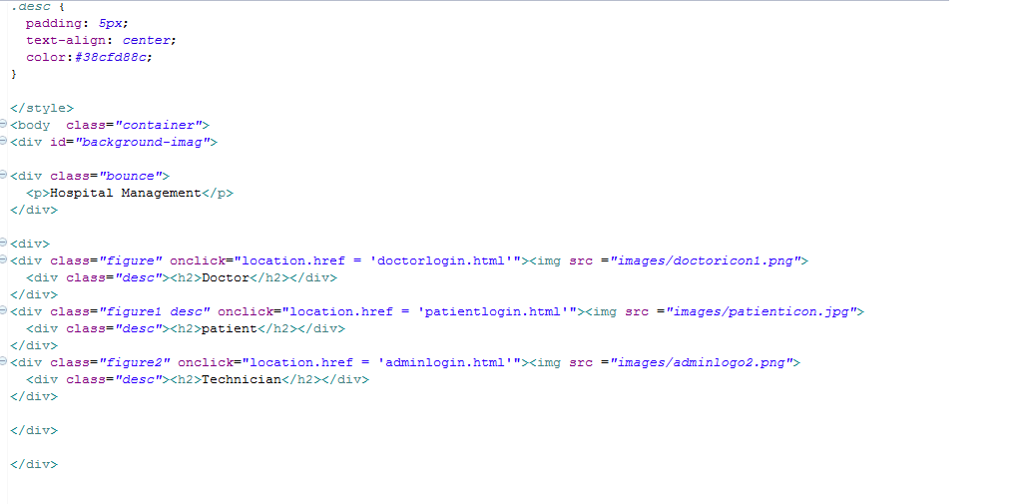

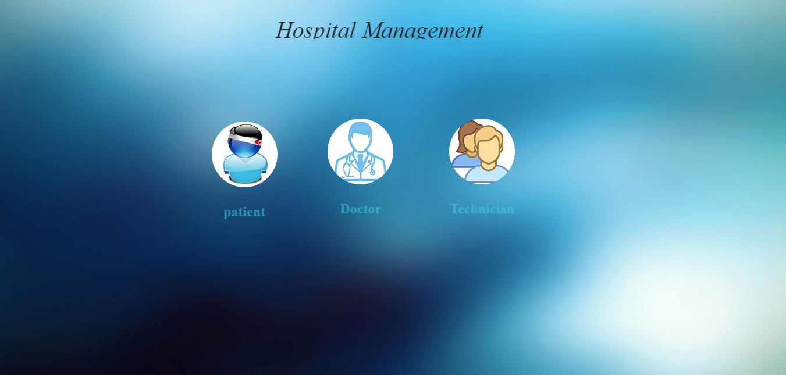

**Doctor login page:**

In this pages I used Html and scss and bootstrap and jquery also. It’s a responsive page and I

was integrated with both login and registration.

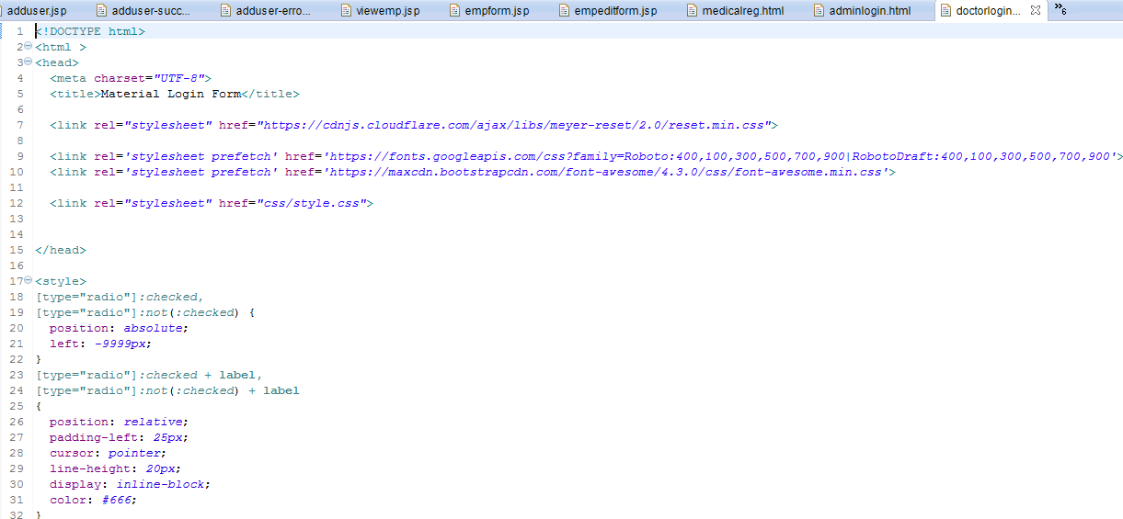

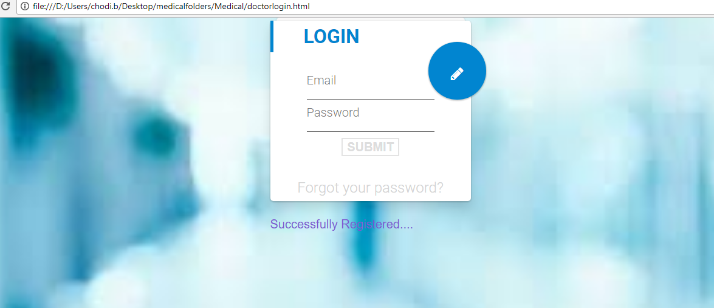

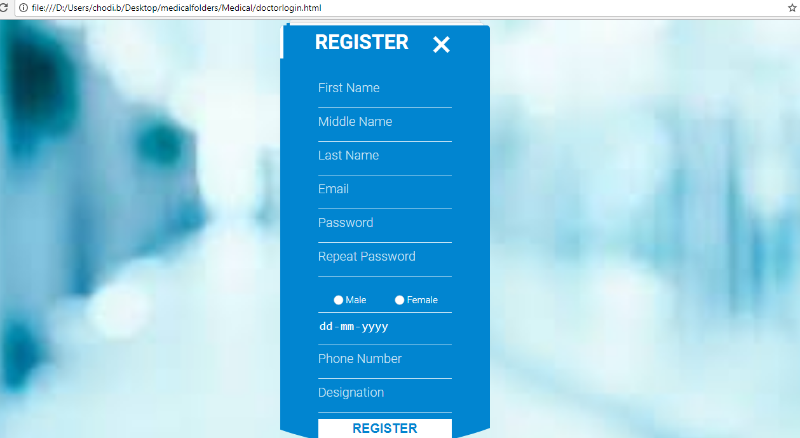

**Doctor form:**

This page is designed by using simple html and css

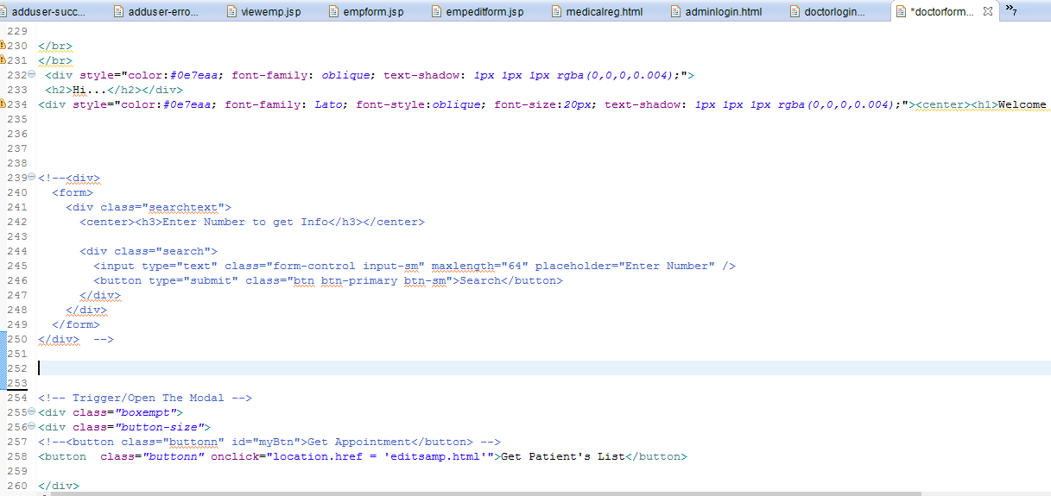



After clicking on get patient list , then below screen will be display.

In the below screen java script is used it can be edit and delete and save.

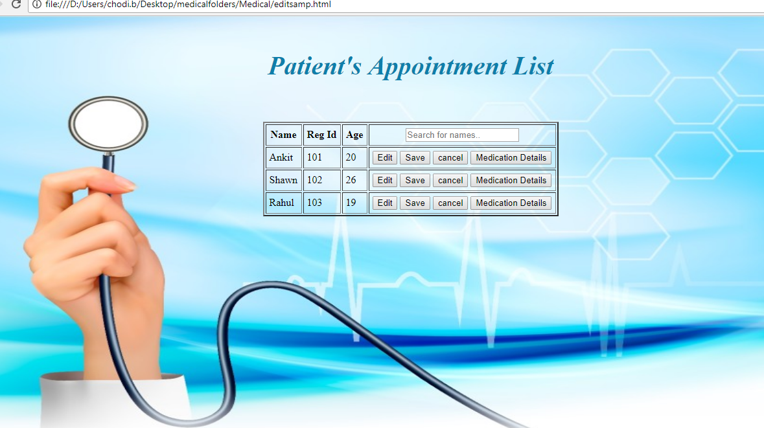

**Appointment:**

This form is designed by using Bootstrap and effects also applied on it.

